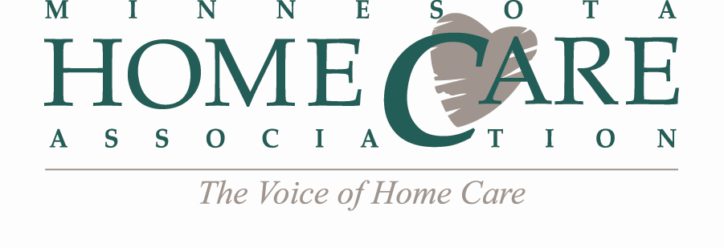
Region Leaders Agenda
Monday, March 5, 2018
2:30 – 3:00 PM
Call-in Number: 1-877-366-0711
Conference Code: 11593782#
AGENDA
- Call to Order
- State-Wide Region Meetings – March 14, 2018
  - Reminder: MHCA will send all meeting correspondence
  - Education In-Service: “Wound Assessment and Management”
  - Schedule: Meetings start at 9:30 am, followed by 10:00 am webinar & 11:00 am regulatory updates. Please test AV prior to meeting start!
  - Deadlines
    - Wednesday, March 7: Meeting Agenda due (MHCA to send template)
    - Fri., March 9: RSVP Deadline for March meetings
    - Mon., March 12: Webinar registration link & attendee list sent by MHCA
    - Friday, March 16: Sign-in sheets due back to MHCA (MHCA to send template)
  - Elections

- Upcoming Education & Events
- April 11 – Medications, Medication Management and More
- May 16-17 – Annual Meeting

- Annual Meeting
  - PAC basket contest

- State-Wide Region Meetings – June 13, 2018
  - Education ideas

- 2018 Region Meeting Dates - Mark Your Calendars!
  - May 16 (Held at MHCA Annual Meeting in Duluth, MN)
  - June 13
  - September 20*
  - December 12
- Other Business
- Next Meeting: Monday, March 5, 2018 (2:00 – 2:30 PM)

- Adjourn
*Note change of date

