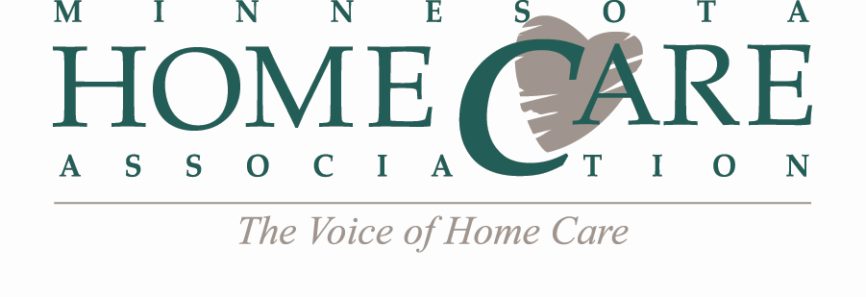
Region Leaders Agenda
Tuesday, November 28, 2017
2:00 – 2:30 PM
Call-in Number: 1-877-366-0711
Conference Code: 11593782#
AGENDA
- Call to Order
- State-Wide Region Meetings – December 6, 2017
  - Reminder: MHCA will send all meeting correspondence
  - Education In-Service: “Including Millennials in the Multigenerational Workforce”
  - Schedule: Meetings start at 9:30 am, followed by 10:00 am webinar & 11:00 am regulatory updates. Please test AV, prior to meeting start!
  - Deadlines
    - Wednesday, Nov. 29: Meeting Agenda due (MHCA to send template)
    - Fri., Dec. 1: RSVP Deadline for Sept. meetings
    - Mon., Dec. 4: Webinar registration link & attendee list sent by MHCA

- Upcoming Education & Events
- Dec. 14 – Medicare Home Health PPS Billing, New Brighton

- State-Wide Region Meetings – March 14, 2017
  - Wound care
  - Other

- 2018 Region Meeting Dates - Mark Your Calendars!
  - March 14
  - May 16 (Held at MHCA Annual Meeting in Duluth, MN)
  - June 13
  - September 12
  - December 12
- Other Business
- Next Meeting: Monday, March 5, 2018 (2:00 – 2:30 PM)

- Adjourn

