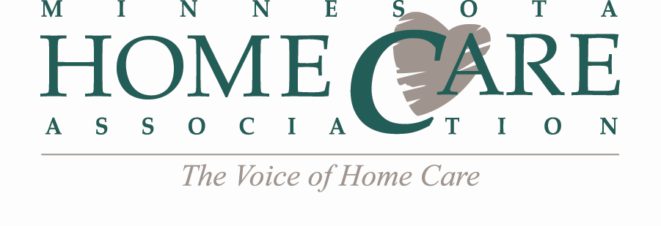
Region Leaders Quarterly Call
Tuesday, January 5, 2016
9:00 - 10:00 am
Conference Call # 1-877-366-0711
Code # 11593782
AGENDA
- Call to Order
- MHCA Region Templates & Tools:
  - Agenda & Minutes Template
  - Region Map
  - Sign-In Sheet
  - CEU Application
  - Current Email Lists – Sent electronically to each Chair
- MHCA Updates:
  - New Communications Schedule
  - New Communications & Member Relations Manager – Start Date January 18th!
- Team Updates:
All Teams: Writing regular Informer articles & many teams are preparing presentations for the 2016 Annual Meeting
  - Clinical Quality Team – Focused on Improving MN 5 Star Ratings – working to determine the cause of the low ratings and developing a plan to educate MHCA members (3-year plan).
  - Education Team – 2016 Education Calendar (attached)
    - Hospice Workgroup – New Hospice/Palliative Care track at Annual Meeting!
  - Legislative Team – 2016 Legislative Priorities (attached) & Grassroots Advocacy articles needed
  - MA Team – DHS is attending February team meeting to discuss PCA Fraud
    - PCA/CFSS/245D Workgroup – New track at Annual Meeting!
    - Home Care Nursing Workgroup – No Update
  - Medicare Team –Tracking new COP & preparing Medicare Team Update(s) for Annual Meeting
  - Membership Team – Applications for 2016 Home Care Professional of the Year Award & working to enhance Membership Benefits based off 2015 Membership Survey results
  - Rehabilitation Team – Upcoming OASIS Cornerstones Webinar February 23rd
  - Survey & Regulatory Analysis Team – Survey Watch on Website in 2016! SRA team wants to hear from members regarding their survey experiences. MDH is attending February team meeting to discuss top survey deficiencies in state.
- Education Needs by Region:
  - What do you need from MHCA to be successful in 2016?
    - MHCA Speaker Database
    - Regional Webinars or Traveling Road Show
    - Region Surveys

- Other Business
- Announce Next Meeting Date: March 29, 2016
- Adjourn

