- If you did not pre-register for the event, a pop up will appear. Please use your Region # as your name.
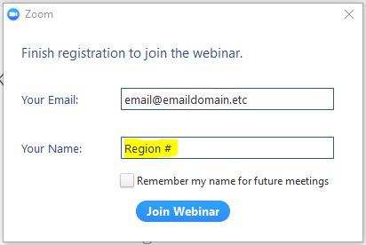
- Your computer may automatically use your computer’s audio and microphone. If you would prefer the phone option, the call-in option would be listed on your confirmation. You are automatically muted when you enter the webinar.
- Meeting icons
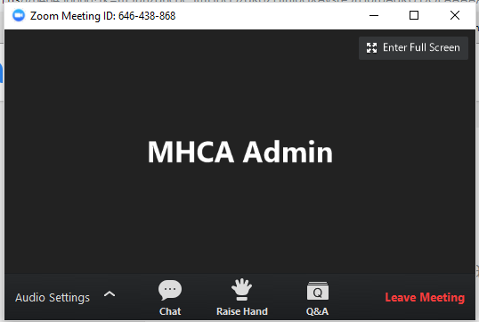
- Audio Settings – You may test your audio settings here
- Chat – This option may be disabled by the host. If not, you would be able to use this to send messages to the host, presenter, and other attendees.
- Raise Hand – Use this if you would like to catch the host or presenter’s attention.
- Q&A – If you have a question, click on the Q&A icon and a pop-up window will appear.

