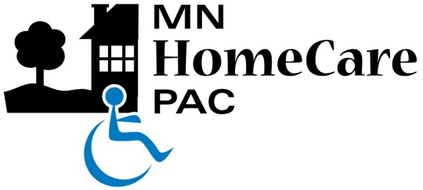 | 2550 University Ave. W.  Suite 350 South  St. Paul, MN 55114  Phone 651-635-0607  Toll Free 866-607-0607  Fax 651-635-0043

Silent Auction/Wine Donation Form
Please complete one form per donation.

- Email the completed form to axiong@mnhomecare.org.
- You can bring donations to the annual meeting exhibition hall at the start of the conference or
- Donated items may be sent or dropped off by May 2, 2017 at:
Minnesota HomeCare Association, 2550 University Ave. W., Suite 350 South, St. Paul, MN 55114
- Note: Donations are not tax deductible and corporate donations cannot be accepted.
- Minnesota law requires full disclosure including employer/occupation.

Name
Address
City/State/Zip
Phone |  | Fax
Employer
Occupation

Donation Description:

Donation’s Monetary Value: | $

Thank you for your generous donation and support.

