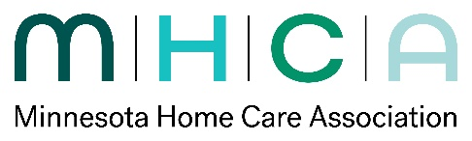
Board Self-Assessment
2026

Topic | 1 – Strongly Disagree | 2 – Disagree | 3 – Neutral | 4 - Agree | 5 – Strongly Agree or Always
- I find serving on this board to be a rewarding and satisfying experience. |  |  |  |  | x
- Overall, the MHCA board is effective. |  |  |  |  | x
- The board composition , taking leadership, professional expertise, constituency representation into consideration. See Governance Criteria. |  |  |  |  | x
- Our board makes its decisions based upon the organization’s vision, mission and values. |  |  |  |  | x
- Our board is effective in ensuring that the organization fulfills its vision, mission and values. |  |  |  |  | x
- Our board maintains sound fiscal oversight and is effective in making responsible financial decisions that support the organization’s ability to achieve its work. |  |  |  |  | x
- Our board is effective in planning for the future of the organization based upon what is best for those served by the organization |  |  |  |  | x
- Our board engages in an effective strategic planning process (development/tracking). |  |  |  |  | x
- Orientation and review of board responsibilities meets your needs for board development |  |  |  |  | x
- Our board shows respect for the intentions and interests of others and for group decisions that are reached. |  |  |  |  | x

Comments:
- If you rated #3 as 1-3, please identify what gaps you believe need to be addressed.

- What additional protocol, training or education would be valuable to enhance board development?

  - I felt the orientation was good and appreciated the book that was done in 2025 regarding the role of the board.

- What suggestions would you have for improving board functioning and the overall success of the organization?
    - No suggestions.

- What are the primary threats or opportunities to the organization over the next 1-3 years? (open ended text)
  - Threats – payment, amount of fraud found in MN (has an impact on everyone)
  - Opportunities – now that the CMS Hospital at Home is guaranteed for another five years, I see this as an opportunity for home care agencies to partner/contract with hospitals that offer this service.

- Other comments you’d like to share.
  - I’ve enjoyed my time on the board and appreciate how well organized the board is, how thoughtful it is in making decisions, and that always keep the needs of the members and organization in mind.
  - Kathy is an excellent leader and will be greatly missed.
  - The board chairs have been every organized and effective in leading the meetings.

