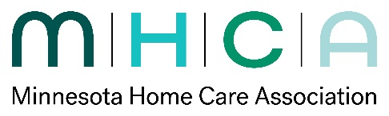
Board Self-Assessment
2023

Topic | 1 – Strongly Disagree | 2 – Disagree | 3 – Neutral | 4 - Agree | 5 – Strongly Agree or Always
- I find serving on this board to be a rewarding and satisfying experience.
- Overall, the MHCA board is effective.
- The board composition , taking leadership, professional expertise, constituency representation into consideration. See Governance Criteria.
- Our board makes its decisions based upon the organization’s vision, mission and values.
- Our board is effective in ensuring that the organization fulfills its vision, mission and values.
- Our board maintains sound fiscal oversight and is effective in making responsible financial decisions that support the organization’s ability to achieve its work.
- Our board is effective in planning for the future of the organization based upon what is best for those served by the organization
- Our board engages in an effective strategic planning process (development/tracking).
- Orientation and review of board responsibilities meets your needs for board development
- Our board shows respect for the intentions and interests of others and for group decisions that are reached.

Comments:
- If you rated #3 as 1-3, please identify what gaps you believe need to be addressed.

- What additional protocol, training or education would be valuable to enhance board development?

- What suggestions would you have for improving board functioning and the overall success of the organization?

- What are the primary threats or opportunities to the organization over the next 1-3 years? (open ended text)

- Other comments you’d like to share.

