Today on KSTP News – 5/20/2019

Minnesota in need of more community paramedics
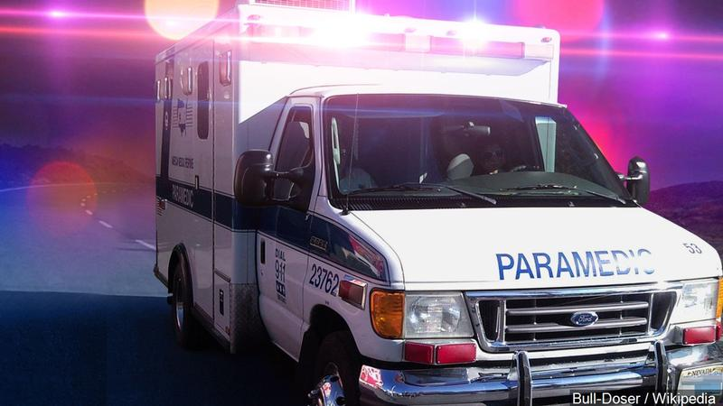Photo: Bull-Doser / Wikipedia / MGN
May 20, 2019 03:47 PM
Department of Health officials say Minnesota needs more community paramedics to assist residents leaving the hospital in managing chronic health conditions at home.
Minnesota Public Radio News reports that the state agency says there are 127 certified community paramedics, nearly half working in the Twin Cities.
Regions Hospital in St. Paul has partnered with the city's fire department and a health clinic on a three-year community paramedic program. The project made nearly 1,000 home visits to help people manage diabetes and high blood pressure.
Nearly half of the program's hypertension patients lowered their blood pressure to a healthy level, while almost 80% of diabetic patients reduced blood sugar levels.
Aaron Burnett, who oversees the program, says patients are coming back to the hospital less and are more satisfied with their care.

