Payer Impacted: BCBS Medicare Advantage plans
How many authorization issues are resulting in denials for our agency? We have had 14 denials. Many partial authorization denials.

Summary of Current Issues: 3/31/26
- BCBS prior authorization process can cause delays in the initiation of care the member is eligible to receive. Prior authorization means authorization before the service is provided (the patient is not under the care of the home care provider before the SOC assessment). If authorization is not approved within 48 hours of the referral being made, home care agencies are not meeting a federal requirement (484.55(a)(1)) and it could seriously jeopardize the life or health of the individual or the ability of the individual to regain maximum function. Another concern is the lack of written consent forms the home health provider would have since the client is not under the provider’s care. Being asked to submit clinical documentation prior to the SOC is an unfair request of the insurance company. Other insurances have handled the prior authorization issue with authorizing the SOC or SOC and Evaluation visits, and then requiring the provider to submit the next request with the orders after the SOC/Evaluation visits.
  - Our Ask: Can BCBS authorize the SOC or SOC/Evaluation visits without needing prior authorization?

- Changes to how BCBS authorizes LPN, PTA, and COTA visits. Previously, providers were able to obtain authorization for PT/PTA or OT/OTA and RN/LPN to cover either discipline (ex-PT or PTA) depending on which provides the visit. For example, if a client was receiving 6 physical therapy visits, auth would be given for 6 PT and 6 PTA so the visit would be covered no matter which discipline was staffed. Lately, BCBS is only approving the total amount of PT – for this example authorizing only 3 PT and 3 PTA. This could mean the authorization may not match the discipline that provided the visit (ex-if 6 visits are staffed with a PT, the provider would only have authorization for 3 of them). This would create a denial that the provider has to appeal.

  - Our ask: Can you please explain why this change occurred and reconsider going back to giving auth that covers the assistants preforming the visits?

- Inability to select exact authorization dates on the pre-authorization request form. The Pre-Authorization Form will not allow you to select a date range before day 14. If the pre-auth request is not submitted within 14 days (providers often wait on signed orders from doctors), BCBS will not retro auth any visits prior to day 14. This means that the SOC date could be affected. If the SOC is not a billable visit it will cause issues with the NOA submission. A new SOC has to be completed so a new NOA can be sent which is confusing to the member as it is an unnecessary assessment driven only by the payer requirement.
  - Our ask: Can this form be adjusted to allow authorization dates prior to day 14 so the SOC date can be reflected in the auth request? If the services are medically necessary and ordered we ask BCBS authorizes the visits, even if an auth request is received on or after day 14.
- Inability to reach the appeals representatives. The BCBS Appeals Department number is 651-662-4357- the number says you reached the appeals department but then when you select the option that you are a provider, it routes you to the general BCBS phone tree which only gives you options for Eligibility, Benefits, or Authorization. When you select the Auth department, you can’t reach a representative and get routed to the benefits department.
  - Our ask: Can you please provide accurate contact information for agencies to use to inquire about appeals?

- Denials for Medical Necessity when the client meets Medicare Criteria under Chapter 7 (BCBS is following stricter guidelines). We have had multiple denials stating services ordered by the provider are not medically necessary, even when the client’s care and services follow Medicare Chapter 7 Criteria (ex-wound care). BCBS often only authorizes a portion of the ordered services which means the member could be responsible for a portion of the ordered services. Agency has been appealing these decisions to advocate for the member. These denials negatively impact the BCBS member and could directly impact the care they receive.
  - Example: Agency asks for 12 SNV, 5 PT, and 3OT visits and BCBS approves: 7 SNV, 3 PT, and 2 OT visits.
  - Do all providers at BCBS know that Medicare Advantage Plans must cover all services Traditional Medicare would cover? https://www.medicare.gov/basics/get-started-with-medicare/get-more-coverage/your-coverage-options/compare-original-medicare-medicare-advantage.
  - Picture of the Criteria:
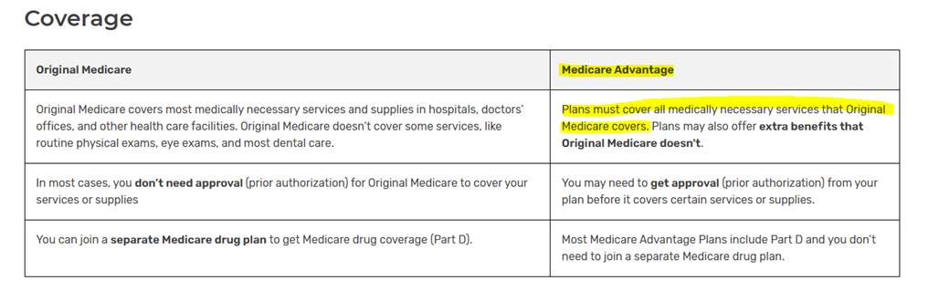
  - Providers can submit complaints about Medicare Advantage plans to CMS if they are not following guidelines outlined here (or for other reasons, like delays in care due to slow prior auth process):https://www.medicare.gov/basics/get-started-with-medicare/get-more-coverage/your-coverage-options/compare-original-medicare-medicare-advantage. Providers may be forced to use this process if BCBS is not covering what Medicare would cover and our clients are being impacted by this.
  - Our ask: BCBS Medicare Advantage plans follow the guidelines laid out in Chapter 7, as this is a regulatory requirement to do so.

- Unreasonable deadlines for additional documentation. When BCBS is faxing letters requesting additional documentation, the turn-around time is unreasonable (often within 24 hours or less) and includes weekends.
  - Example: On 3/25/26, provider received a fax at 12:54pm requesting additional information by a deadline of 3:02pm same day. If the provider did not fax the documents within the short timeframe (within 2 hours), the auth request will be denied in Availity.
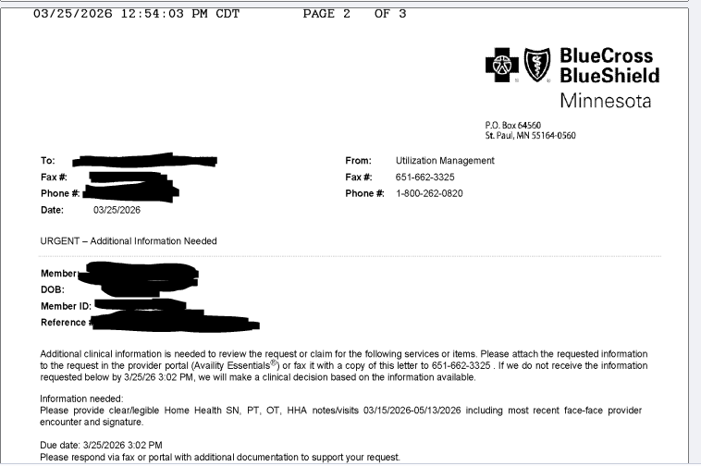
  - Example #2: Provider received a request for clinical documentation to be resubmitted related to the pages not being clear. The BCBS fax was received on 3/23/26 at 2:20PM CT and gave a deadline of 3/24/26 at 12:30AM for the provider to submit the documents by fax (2 hrs and 40 minutes during business hours). Agency did not see the fax until the following morning on 3/24/26, at which point it was too late and was denied.
  - Example from the request:
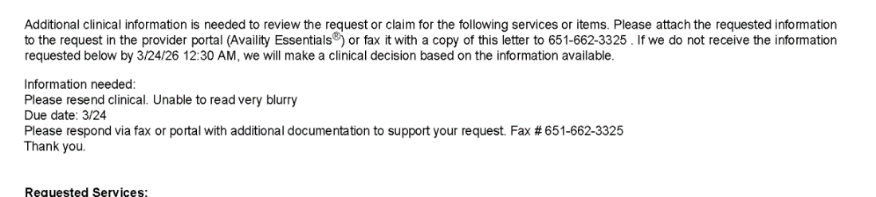
  - Our ask: Give agencies a reasonable amount of time to respond to these requests. 48 business hours would be reasonable.
- The Availity website does not match the paper authorization approved from BCBS. For example: the Availity website will show 3 visits as approved, but the BCBS letter will show 7 visits approved. We are concerned about the differences between the paper authorization letters and the Availity listings, which one is correct, and how our claims will process.
  - Our ask: Availity and the BCBS paper authorization reflect the same authorization approvals.

