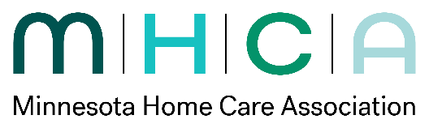 | Medicare Workgroup  Meeting Agenda  Date: 3/18/2026
Committee Members:
☒ Barb Jezorski, Chair ☒ Margaret Krull, Vice Chair ☒ Katie Troumbly, Board Liaison ☒ Stephanie Andersen
☒ Jill Arvidson ☒ Dawn Bratlien ☐ Mary Burns ☒ Rachel Eastwood
☒ Alex Foss ☒ Alessa Germolus ☐ Teri Henning ☒ Kim Holien
☐ Jennifer Stark ☐ ☐ ☐
Others Present:
Staff Present: Paulette Duncan
Agenda Item | Discussion | Motion and Vote Follow-Up or Action Item | Responsibility | Deadline
1. Call To Order
2. Approval of Minutes | Approval of 1/19/26 meeting minutes
3. Advocacy Update | Day of advocacy was successful. AL in home care advocacy committee, determine how to use the dollars. Have 1 year to let commissioner know. MHCA collaborated at press conference to require insurance provide HCN coverage. Medica try to cap 10 hrs per year.  Other bills stemming from Medicaid fraud-1) PCA bill, 2) employers requiring to request work breaks (exemption language for home care) 3) Pre- audits, Payment withheld from providers. 4) BCBS- meeting set up for April 2nd. |  | - Paulette
4. New ABN | New ABN is not completed and supposed to use current version. | - TBD- as of posting minutes 3.19.26 PLEASE NOTE:  The ABN was updated-  Advance Beneficiary Notice of Noncoverage (Form CMS-R-131).  We can use the expired version of the ABN until May 12, 2026, but must transition to the approved form no later than that date. New version expires 3/31/29.
5. BCBS | Paulette has a meeting set up for 4/2. 12 denials on agency and not accepting unsigned 485s and must be signed within 14 days. Modified prior auth request for VO COP, and provide care within 48 hours COP.  Sending unsigned POC and have VO SOC date with appropriate diagnosis. Other agency have verbal orders. Past claims from 24/25 issue due to ‘noa not on file’ BCBS states still lookin and ‘behind’ Evality program has no notice of admission. Response from Feb: BCBS moved to clinical prior aut from automated systems. Working with regulatory timeframes. Will continue to monitor turnaround times. BCBS are negotiating number of visits with some agencies. Example of partially approving auth visits. Agency appealing and BCBS stating a physician and not NP approve additional. Idea: member calling sometimes helps.  Stating ‘visits don’t match diagnosis however mismatch with what agency provided. Example- SN PICC line x 10 weeks and only approved 5 weeks.  BCBS has not been approving PRN visits. What has been clinical support? Initially no one to speak with. Getting someone however inconsistent answers . Denied auths have been stated they will be ‘relooked at, re-reviewed’ Example 23 denials and continue to serve patients however in appeal and clients getting denial letters. Staff retrained that POC can be signed by allowed practioner. Verbal Orders are acceptable. Re-reviewing denials solely based on unsigned POC in 14 days.  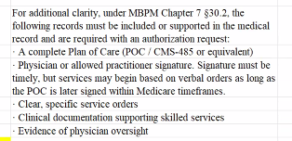 | Email Paulette of any issues related to denials or billing issues with BCBS by April 1st, 2026.  - See attached information | - Jill/Paulette
6. UCare | MN owes UCARE money, and no payment date in sight. Will keep this group updated for any changes. | - Updates TBD
7. Clinics not giving verbal orders | Health Partners, Mayo, Have the initial order, and call for clarification order. Enter order, FAX, then wait for return before providing care. There are delays in patient care due to waiting. for orders. Provider concern are things different on POCS than the verbal orders they were approving. Requires additional patient communication re orders and expectations.  DO Agencies still review Med list by RN for a PT SOC? Not required however it depends on your agency policy. Recommend review policies. |  | - Barb J
8. Wrap-Up/ Miscell Topics | F2F document-  Wound Care no changes/chronic and appeal being told to continue services VS ADR that state skill isn’t reasonable and necessary  Supply Company/ Billing outpatient to Home Care Episode.  Virtual Therapy Visits | Review tipsheet and send suggestions to Paulette or Barb for May Meeting final review.
9. Adjournment
Next Meeting Date & Location:

